Final Analysis Insight of Assignment 1

Project Title: PRODUCT INNOVATION HUB

Introduction: In this report Analyses Product Data set.

Key fields: Product ID, Product Name, Brand Name, Price, Quantity, Category, Total Price, Price Range, Day, Country Code, Month

- Data Summarization:
SUM, COUNT AND AVERAGE FUNCTIONS

- SUM FUNCTION: In this function we using calculation of totals, subtotals and summarizing data.
Syntax: FORMULAE: =SUM (D2:D35*E2:E35)
Screenshot of Sum Table:
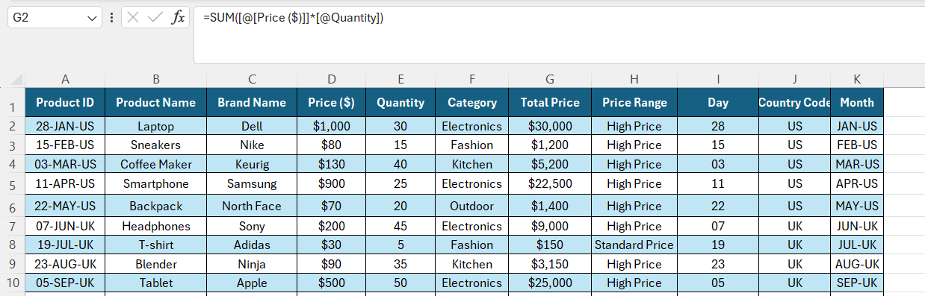

Answer: Total Price of All Products: $2,89,700

- COUNT FUNCTION: Count function is always counting only Numeric value and Integer and Decimal value. The count Function not string text format.
Syntax: FORMULAE: =COUNTA (B2:B35)
Screenshot of Count A Table:
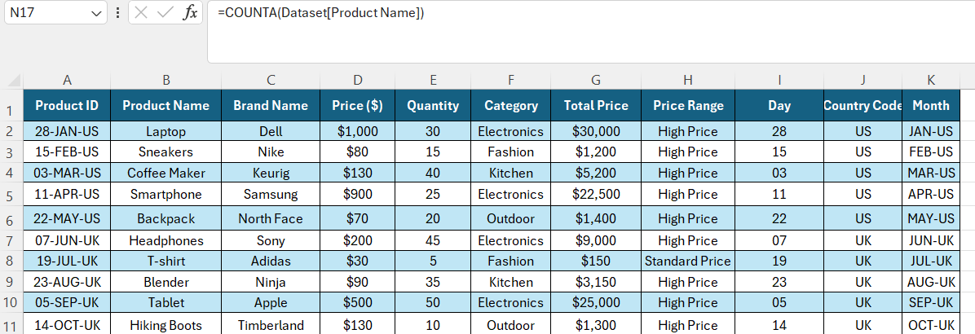

Answer: Total Number of Products: 34

- AVERAGE FUNCTION: Count function is always counting only Numeric value and Integer and Decimal value. The count Function not string text format.
Syntax: FORMULAE: =AVERAGE (G2:G35)
Screenshot of Average Table:
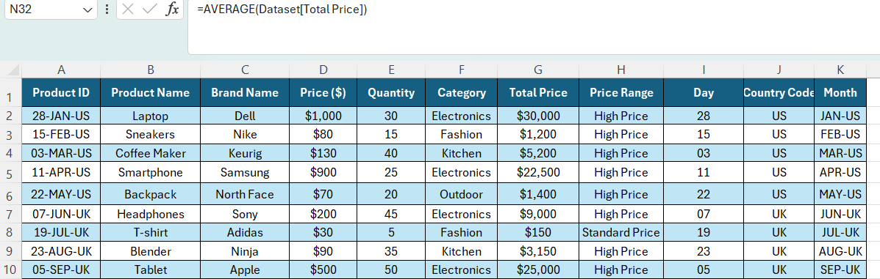

Answer: Average Price of the Products: $8,521

- Data Range Analysis:
MIN AND MAX FUNCTIONS

- MIN FUNCTION: Calculating minimum value of Price Range.
Syntax: FORMULAE: =MIN (G2:G35)
Screenshot of MIN Table: 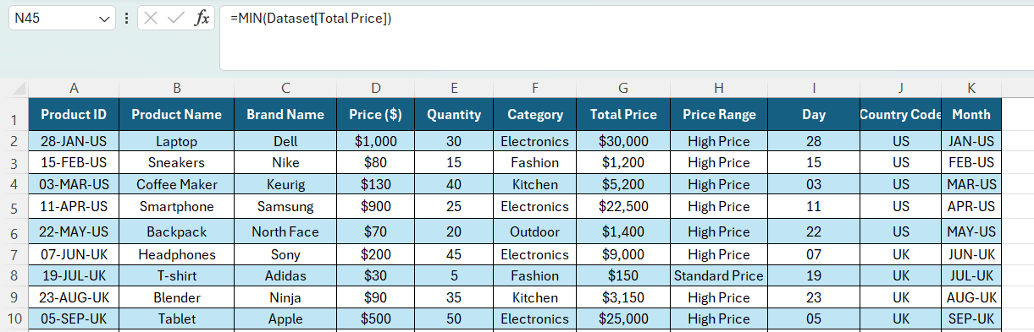

Answer: Minimum Price of All Products: $150

- MAX FUNCTION: Calculating maximum value of Price Range.
Syntax: FORMULAE: =MAX (G2:G35)
Screenshot of MAX Table:
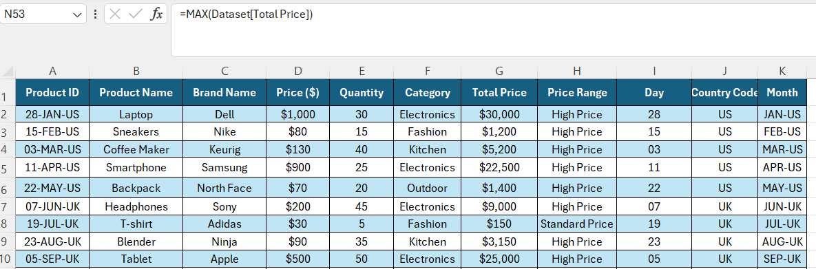
Answer: Maximum Price of All Products: $36,000

- Logical Function:
IF FUNCTION
- IF FUNCTION: It is fundamental tool. Performing comparisons between test result TRUE or FALSE.
Syntax:

FORMULAE: =IF (G2>=500,"High Price”, IF (G2<500,"Standard Price”, “Low Price"))

Screenshot of NESTED IF Table:
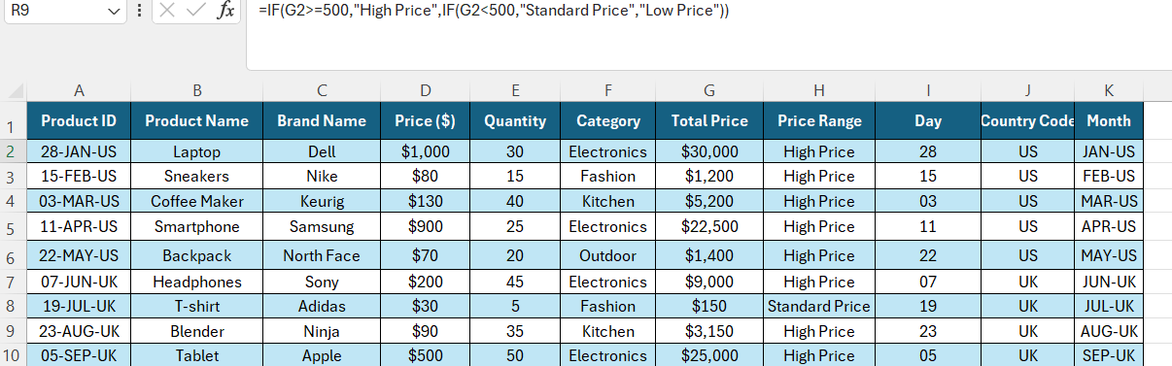
Answer: Price Range: "High Price"

Syntax: FORMULAE: =IF(G8>500,"High Price”, “Standard Price")
Screenshot of IF Table:
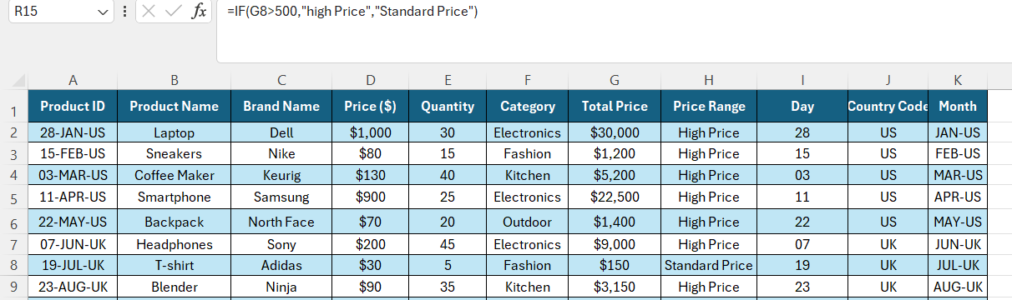

Answer: Price Range: "Standard Price"

- Condition Functions:
SUMIF AND COUNTIF FUNCTIONS

- SUMIF FUNCTION: SUMIF allows you to sum value. You need apply range criteria, sum range. Specified range are Summed.
Syntax: FORMULAE: =SUMIF (F2:F35,"Electronics”, D2:D35)
Screenshot of SUMIF Table: 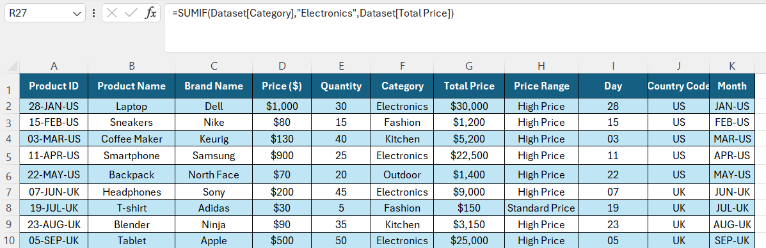

Answer: Total Electronics category: $2,34,200

- COUNTIF FUNCTION: Counts the number of “Occurrence” that’s satisfy a given condition. Key point is Conditional counting.
Syntax: FORMULAE: =COUNTIF (D2:D35,"<100")
Screenshot of COUNTIF Table:
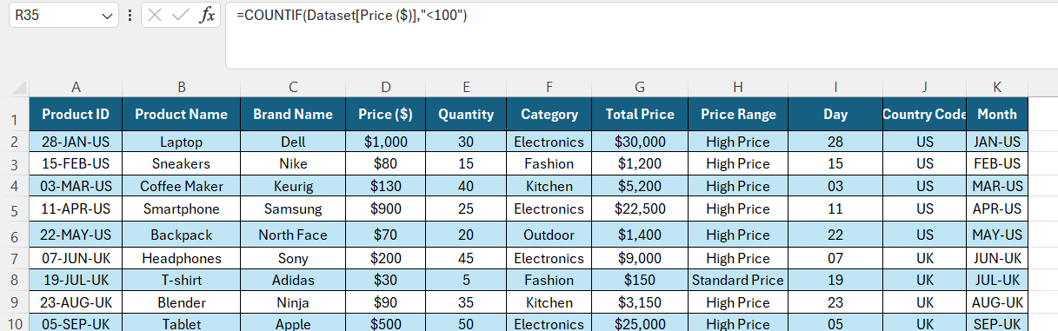
Answer: Number of Products with a Price less than: $11

- Text Functions:
LEFT,RIGHT AND MID FUNCTIONS

- LEFT FUNCTION: Can be used limit the number of characters displayed from left side of text string.
Syntax: FORMULAE: =LEFT(A2,2)
Screenshot of LEFT Table 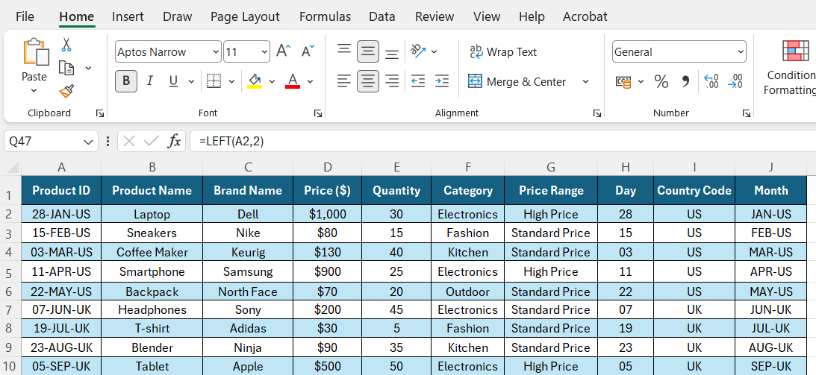
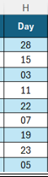
Answer: Day: 28

- RIGHT FUNCTION: Can be used the number of characters displayed from right side of text string.
Syntax: FORMULAE: =RIGHT(A2,2)
Screenshot of RIGHT Table 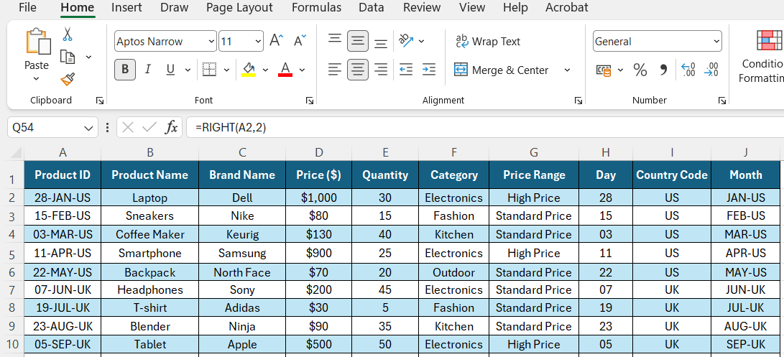
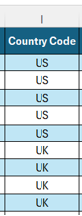
Answer: Country Code: US

- MID FUNCTION: Extract a sub string from middle of text string.
Syntax: FORMULAE: =MID(A2,4,6)
Screenshot of MID Table 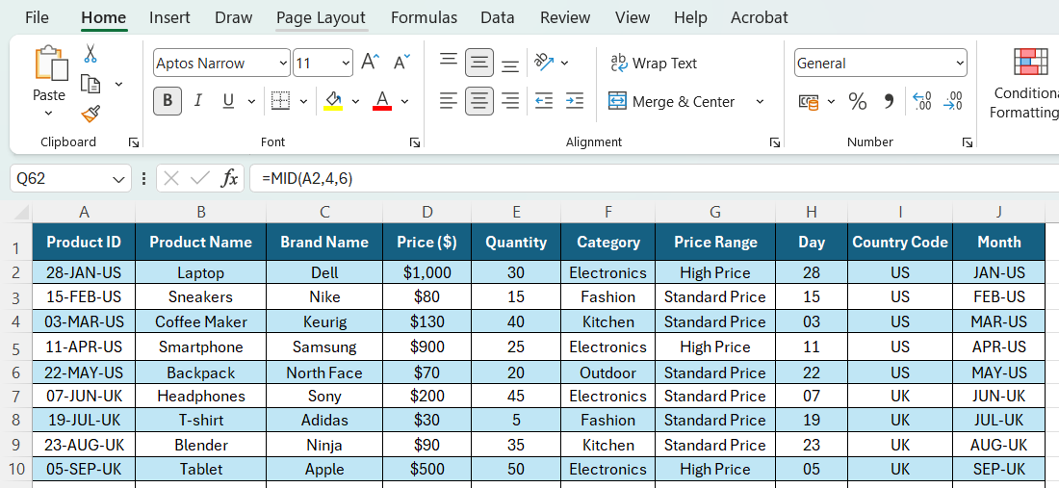 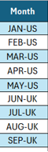
Answer: Month: JAN-US

Conclusion: In this Price Analysis the above mentioned using all functions in the excel we will get quick analyses of summary, visualizations of table we can easily understand to analysis in product Innovation Hub.

